

Proteus: Indie Production Paperwork Guide
Document History
Version | Date | Author | Comment
1.0 | September 2019 | Lucy Walters | Created
2.0 | November 2019 | Lucy Walters | Updated to reflect current processes
3.0 | March 2023 | Martin Johnson and Shiromi Ramanayake | Updated to reflect current processes
Contents
1 Introduction 3
1.1 Timescales 3
1.2 Support 3
2 Access to Proteus 4
2.1 Audit Trails 4
3 Logging In 4
3. 1Troubleshooting Tips 5
4 Public Facing Data 6
4.1 Before You Start 6
5 Search for Your Programme 6
5.1 Progress Indicators 7
6 Edit Descriptions 7
6.1 Descriptions Top Tips 9
7 Confirm Descriptions 9
8 Public Facing Data - FAQs 10
8.1 Can I update my descriptions later? 10
8.2 Can I update after a programme has been broadcast? 10
8.3 Do I have to write 5000 characters for the long description? 10
8.5 Do I have to add an episode title? 10
8.6 How do I credit casts and producers for Dramas? 10
9 Compliance Information 10
9.1 Compliance Details Entry 11
10 Compliance Authorisation 12
10.1 Producer Confirmation 13
10.2 Network Authorisation 13
10.3 Compliance Status Indicators 13
10.4 Printing/Exporting Compliance Forms 14
11 Running Order Data 15
11.1 Before You Begin 15
11.2 Adding the Production Team 15
11.2.1 Create New Person 17
11.2.2 Adding Content Items 18
11.3 Adding Contributors 19
11.4 Adding Archive Items 20
11.5 Adding Music Items 20
11.5.1 Music Reporting Codes 21
11.6 Paperwork Complete 23
12 Music Report 23
13 Sending the Music Report 24
14 Correcting Errors When the Music Report Has Been Sent 26
1 Introduction
This guide demonstrates how Indie Paperwork Users should make use of Proteus.
The BBC Academy homepage for Proteus for Independent productions is here:
https://www.bbc.co.uk/academy/proteus

If you need information on submitting proposals, this is available on the Radio Commissioning page here:
http://downloads.bbc.co.uk/radio/commissioning/proteus-commissioning-guide-independent-suppliers.pdf

If you need information on programme delivery, this is available on the Radio Commissioning page here:
https://www.bbc.co.uk/commissioning/radio/making-content/delivery-what-and-when/
The information entered into Proteus should be robust, detailed and accurate as this data will become part of the BBC archive and the Titles and Descriptions will be published on BBC web sites, BBC Sounds and EPGs.

1.1 Timescales
Descriptions must be completed in advance of the programme transmission. For pre-recorded programmes, compliance must be completed in advance of the programme transmission.
Running order data can be added in advance of the programme transmission, but music reporting can only be sent from one hour after the programme has been transmitted onwards. Music reporting is not required for programmes whose reporting is completed via dira! or SADiE.

1.2 Support
If you have any editorial queries (how long a description should be, how to report a specific item etc.) please contact the Network that is transmitting or publishing your programme. Your Network Contact will be the person who gave your company the programme commission.
If you are unable to proceed with any of the tasks listed below, please contact Proteus Support: proteus.support@bbc.co.uk

2 Access to Proteus
To log in, you will need to use the username provided by Proteus Support for the “Indie Paperwork” site.
The username for the “Paperwork” site will end in 01, 02, 03 etc. If your username ends in 00, you will not be able to log in to the “Paperwork” site (as this ‘00’ username is for submitting proposals) and will need to contact proteus.support@bbc.co.uk

2.1 Audit Trails
A “Paperwork Account” (ending in 01, 02, 03 etc.) will be your personal account, any actions that you take within the system will be tracked and visible in programme audit trails. Your name will be listed in these audits, so that other users can see who has made each update to the data for each programme.

3 Logging In
The link to log in to the “Paperwork” site is here:
https://proteus-external.tools.bbc.co.uk
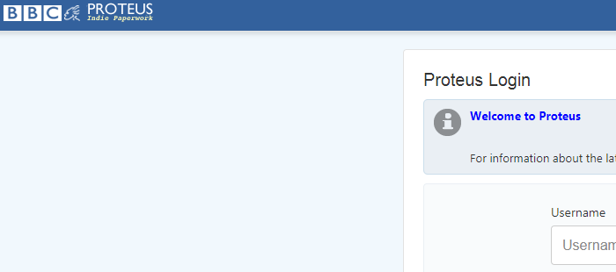
You can check that you are logging into the right site by looking at the logo in the top left corner of the screen. If you are on the right page the phrase “Indie Paperwork” will show beneath the Proteus Logo.

TIP: Proteus works best in the latest versions of either Google Chrome or Microsoft Edge. Other browsers may not support full Proteus functionality.
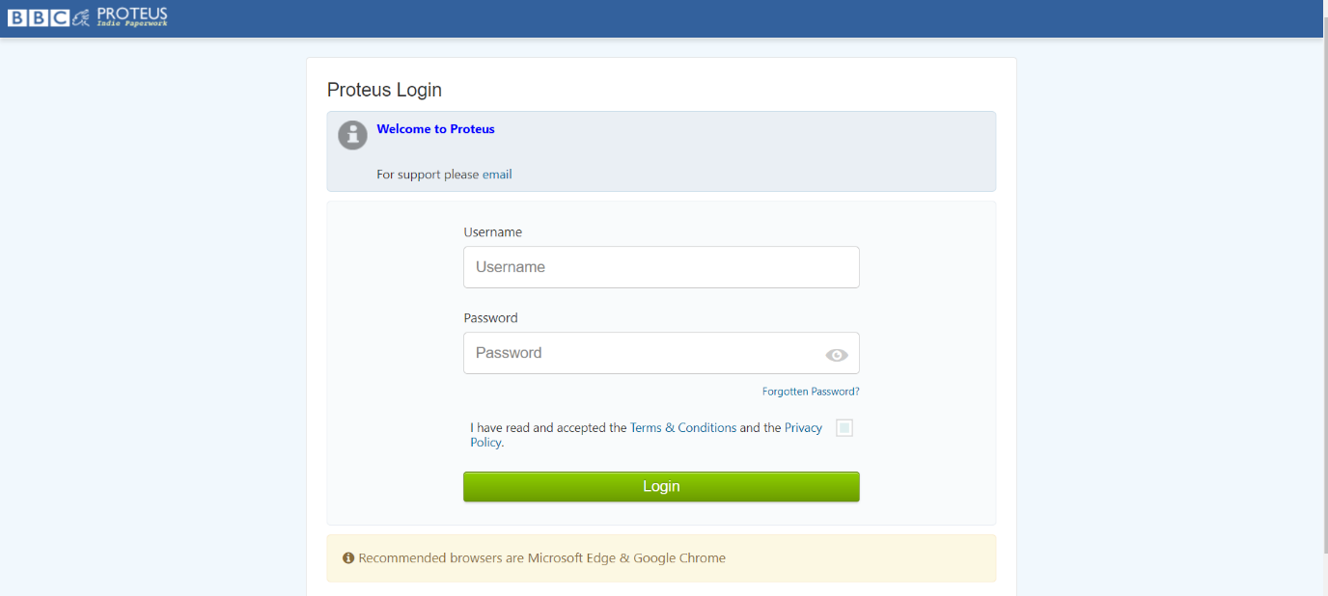
To reveal your password and check that you have entered it correctly, click the eye icon to the right of the password field. The “Paperwork” site has a two factor authentication system, which means that a text message will be sent to your chosen phone number.
Once you have entered your password, username and confirmed that you have read the T&Cs and Privacy Policy, you will be taken to this screen:
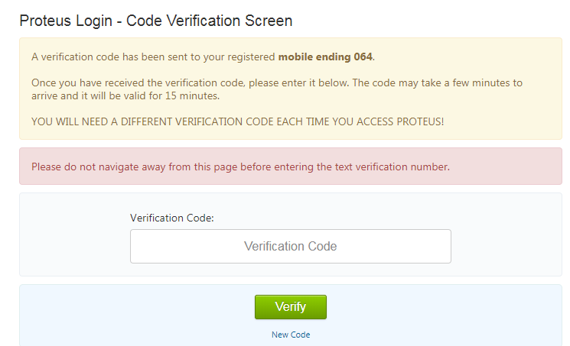
Enter the code sent to your phone to access the site. This may take a few moments to arrive. If the code is not received you can request a new code.
If the code is not received please contact proteus.support@bbc.co.uk

3. 1 Troubleshooting Tips
If your phone is lost or stolen, please contact Proteus Support from the email address that is linked to your account.
If you are in an area with poor phone signal, please let Proteus Support know.
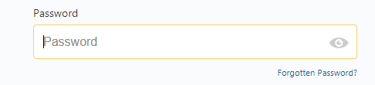
If you have forgotten your password, please click the “Forgotten Password” link below the password field:

WARNING: Your password will expire every three months. You will need to use the Forgotten Password link to reset it.

4 Public Facing Data
“Episode Titles” and “Descriptions” are public facing data and what you enter will be published on the BBC web sites and apps. It will also appear on EPGs and Press listings.
To enter and edit “Episode Titles” and “Descriptions” you will need a Proteus “Paperwork Account”.

4.1 Before You Start
The following tips are important to remember before you start editing programmes in Proteus:
- There is no autosave function in Proteus. Save your work regularly as this will avoid the loss of work.
- Avoid leaving Proteus open but inactive for more than ten minutes, as you may be automatically logged out and lose your work.
- Avoid opening Proteus in multiple tabs or windows. This may cause errors and result in the loss of your work.

5 Search for Your Programme
To search for your programme, always use the programme title and TX date – or the Proteus “Programme Number” if you have it.
Navigate to the “Programme/Transmission” Search on your home page.
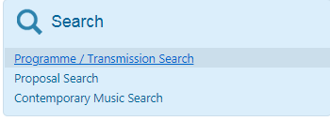
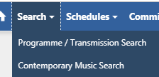
You can also access the search function via the drop-down at the top of the screen:

Once you have found your required programme, click on the “Descriptions” link:
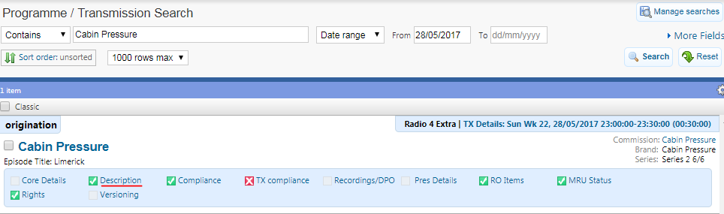

5.1 Progress Indicators
In your search results, you will be able to see boxes next to the “Description”, “MRU Status”, “Compliance” and “RO Items” boxes.
Red = Not Edited
Yellow = In Progress
Amber = Complete
Green = Approved

6 Edit Descriptions
“Descriptions” display on public facing sites and apps, such as BBC Sounds, changes from Proteus will be published shortly after you have updated them, so make sure that the information is all correct.
The Academy training page for updating descriptions is available here: https://www.bbc.co.uk/academy/proteus/programme-descriptions/
Click the “Edit” button to the top left of the “Public Facing Information” box to add an episode title.
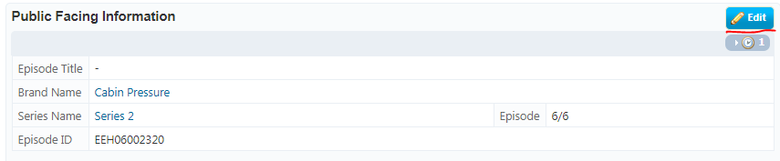
Add your title, and click the “Save” button – which will appear in place of the “Edit” button:
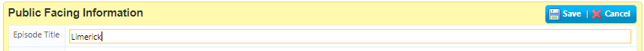
To edit the descriptions, click the edit button at the top right of this section and edit your information.
The character limits for the descriptions are as follows:
Short – 90
Medium – 180
Long – 5000
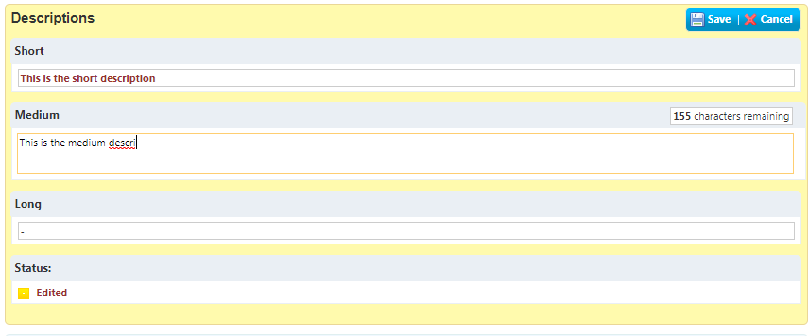
The number of characters available will be displayed on the page while you are editing, and will decrease as you type.
It is possible to add characters beyond the count, but not to save a description that is over the character limit.
Save your descriptions.

6.1 Descriptions Top Tips
- Your descriptions must be compliant with the BBC Editorial Guidelines which are available here:
https://www.bbc.co.uk/commissioning/radio/editorial-risk-and-compliance/
http://downloads.bbc.co.uk/radio/commissioning/compliance_form_guidance_note_march_2015.pdf
- Do not depend on your spellchecker. Make sure somebody else proof reads your descriptions for you.
- Good grammar and spelling are essential.
- Remember to periodically save to avoid losing your work.
- For information and advice on how to write descriptions follow this link: http://downloads.bbc.co.uk/radio/supportsite/BBC-Editorial-Guide-to-Metadata.pdf
- Everything that you do will be recorded in the Proteus Audit for the programme, to access this click on the Clock symbol at the top of each description box:

7 Confirm Descriptions
There are two options listed under “Actions” at the bottom of the page. You only have permissions to click the “Complete” button, which you can do once you are sure your Descriptions are ready for the public to view.
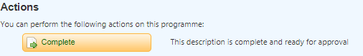
Once you have clicked “Complete”, you will need to notify a user at the Network that your programme descriptions need to be approved.
WARNING: Changes to these pages will update on the public facing sites shortly after being approved so make sure the information that you update is accurate.

8 Public Facing Data - FAQs

8.1 Can I update my descriptions later?
You can make changes, but these will need to be approved again. Nothing goes live on public facing sites until it is approved.

8.2 Can I update after a programme has been broadcast?
Updates can be made and approved in Proteus up to 7 days after TX. After this point please contact Proteus Support if you need to make changes.

8.3 Do I have to write 5000 characters for the long description?
Around 1800 characters is appropriate for BBC Sounds and should be sufficient for most programmes. 5000 characters are available for Dramas and classical music programmes on Radio 3.

8.5 Do I have to add an episode title?
Check the following link for advice on adding episode titles: http://www.bbc.co.uk/programmes/articles/47Cs3LzWJtZG91S7v4NdKnb/programme-listings

8.6 How do I credit casts and producers for Dramas?
To find out how to do this, please follow this link: http://downloads.bbc.co.uk/radio/supportsite/Metadata-for-Drama-and-Readings.pdf

9 Compliance Information
Compliance is an essential part of the production process and must be completed for all pre-recorded radio programmes. This information should capture any content in the programme which may influence the time at which it is broadcast, or makes it unsuitable for a certain audience.
The Academy training page for adding compliance is available here: https://www.bbc.co.uk/academy/proteus/programme-compliance/
How to ensure your programme is fully compliant is available here:

https://www.bbc.co.uk/commissioning/radio/editorial-risk-and-compliance/#complianceform

Guidance on live output can be found here: https://www.bbc.com/editorialguidelines/guidance/live-output

9.1 Compliance Details Entry
You can access compliance either through the link on your search results or via the “Compliance” tab at the top of your programme, next to the “Transmissions” tab.
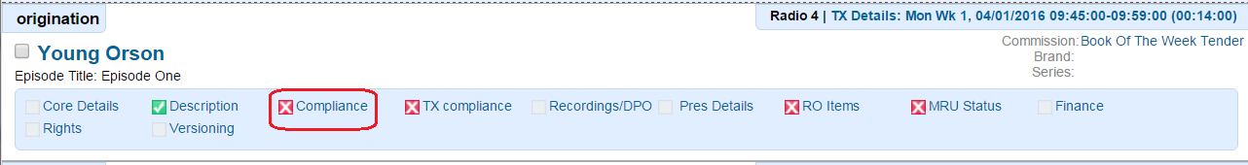

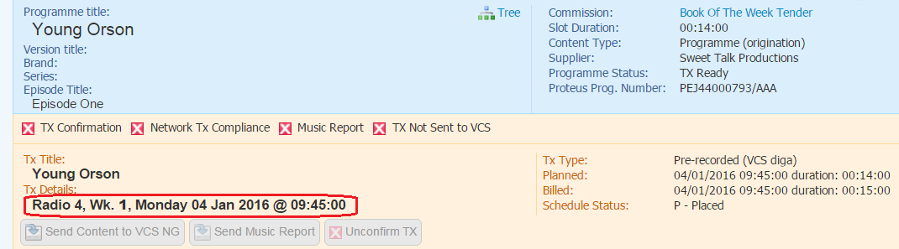
Check the programme “TX Details” to ensure you comply the correct programme:

For reference, there are links to BBC Editorial Guidelines information at the top of the form and links alongside each compliance field.
Click “Edit” to begin the compliance form:
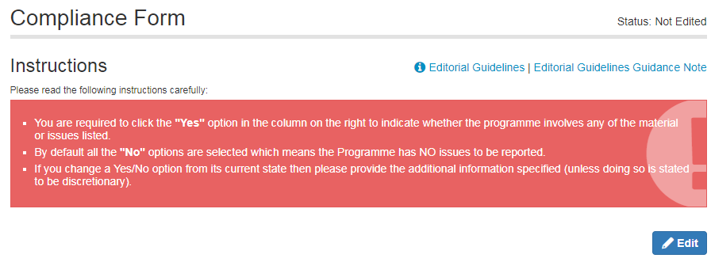
Each question has a “YES” and “NO” choice box next to it. The default is set to “NO”:
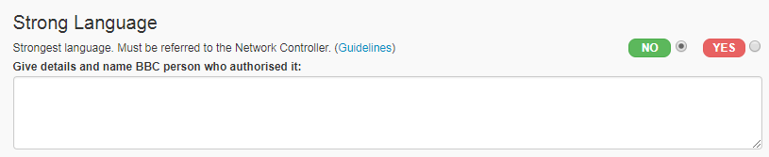
WARNING: Leaving the default option as 'NO' indicates that there are NO relevant issues with the programme. Selecting 'YES' to any question indicates that there are issues with the programme.

If you click the “YES” option, you need to add further information in the comments box alongside the question. Text above the comment box will guide you as to what is required.
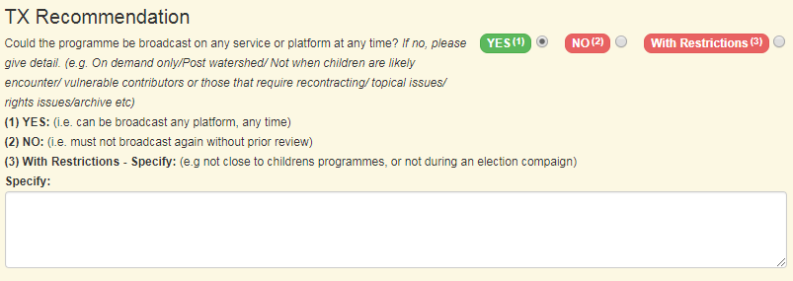
Having completed the “YES/NO” questions, the next section contains a series of free text boxes for you to enter any relevant information.

There are 3 choices related to the following question:
“Could the programme be broadcast on any service or platform at any time?”
- Click “Yes”, if the programme can be repeated without restriction.
- Click “No” if the programme must not be broadcast again without prior review (for most controversial programmes).
- Click “With Restrictions” if the programme can be repeated with restrictions, select this option and fill in the restrictions that apply.
Once you have completed the form click “Save.”

10 Compliance Authorisation
Once you have saved the compliance form details you will need to scroll down towards the bottom of the screen to locate the authorisation sections, as shown below. For compliance to be complete, two confirmations are required, one from the Producer and the other from the Transmitting Network.

10.1 Producer Confirmation
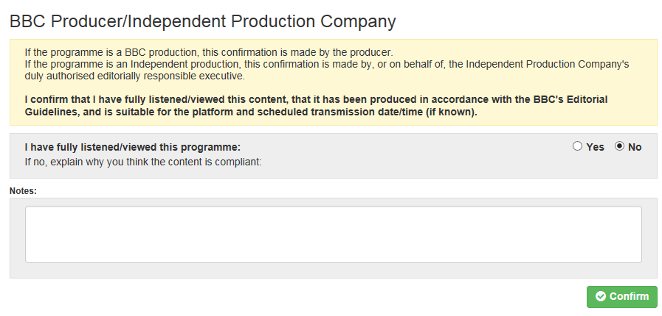
The Producer provides confirmation that the programme content adheres to the BBC Editorial Guidelines.

The Producer who completes the original set of YES/NO options and free-text boxes needs to ensure there is enough information on the form for the Network to be able to sign off in the case of any future repeat.

10.2 Network Authorisation
The transmitting Network (or a nominated delegate such as an Editor) must provide confirmation that the programme has been approved and is compliant for the transmission time or publishing channel.

10.3 Compliance Status Indicators
Each programme has a compliance status indicated as follows:
 | Never edited.
 | Edited and saved (whether or not comments added).
 | First level (Producer) sign-off has been completed.
Second level (Network/Editor) sign-off has been completed (this approval is per transmission):
 | Not Approved.
 | Approved.
The statuses for programme “Compliance” and Network “TX compliance” are displayed on the search results page. This allows you to see what stage the form is at before you open it.
The screenshot example, below, shows that the compliance form for the programme has been signed off at the first level by the Producer, while the compliance sign-off for the transmission has yet to be completed:
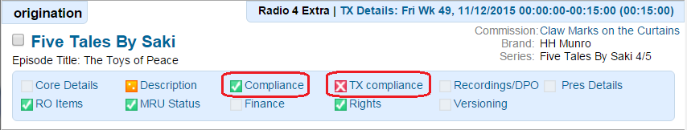
The programme compliance status is also displayed on the tab at the top of the “Compliance” page.
The “Network TX Compliance” status is displayed on the right hand side of the transmission details:
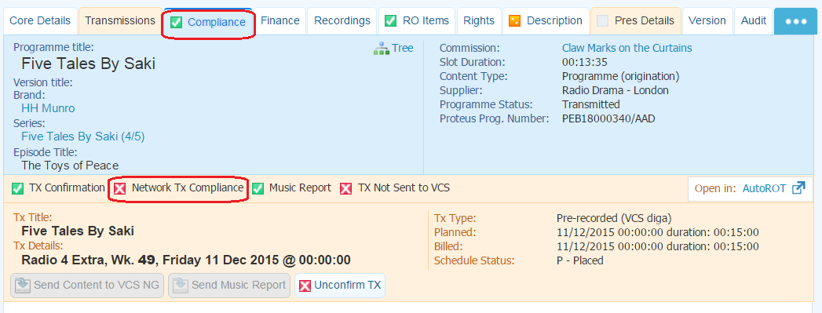
Proteus does not automatically e-mail compliance status updates. The data sits in Proteus for reference and users who need to sign off the different compliance levels must log into Proteus and search for programmes to view the compliance status and take any relevant action.
If you need to update the compliance for a programme after saving, you can do this but your compliance will need to be re-approved, by both you and the Network.

10.4 Printing/Exporting Compliance Forms
Forms can be printed by clicking the 'Print' button located at the bottom of the compliance page or by clicking the printer icon in the browser bar at the top. The information can be exported using the button at the bottom of the page.

11 Running Order Data
Running order data, or “RO Items”, refers to the non-public-facing content descriptions, contributor, music and rights information on Proteus. Running orders record who contributed to a programme and what happened in it.
This data is added to the BBC Archives for your programme. It will help any future users who want to know exactly what happened in your programme.
Parts of your programme could be used as clips by other productions. In this case it is really helpful to have detailed information on the events of the original programme.
The Academy training video for adding running order data is available here: https://www.bbc.co.uk/academy/proteus/running-orders

11.1 Before You Begin
Before you begin editing your running order, gather together the following information:
- Title and transmission date of your programme(s)
- All the names of the contributors, their roles, and their rights agreement type
- All the music details for any tracks used (CD covers or discogs.com listings)
Having all this information before you start will make the process much easier and decrease the risk of incorrect data being entered into the system.

11.2 Adding the Production Team
The academy training video for adding Production team is here: https://www.bbc.co.uk/academy/proteus/running-order-add-your-production-team/
TIP: If you are unsure how to report a specific content item, please contact the Network that is transmitting your programme.
To add a name, click on “Add Team Members” button, the green plus sign at the right hand side of the “Production Team” field. This will open a pop-up window.
TIP: Don’t worry about the field which says “Programme Contributors” – this field is a legacy field and is no longer updated.
Type in the name you are searching for.
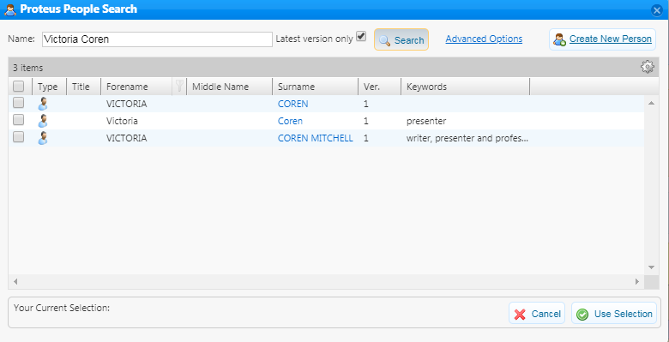
When you find the person you are looking for, please select them by checking the box to the left of their name.
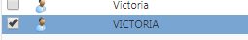
Then click “Use Selection”
You will then need to select the role performed by this contributor from the drop down, and add the relevant rights information.
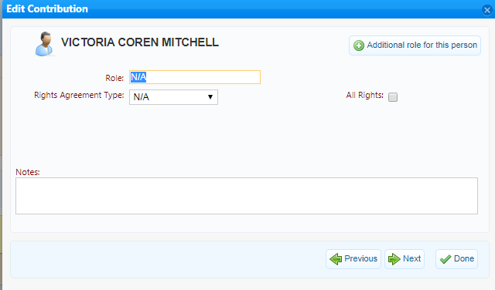
The best field to use for a general production team member is “Radio Production.”
Repeat until you have added the whole team. Once you have added the names, make sure you click “save”.
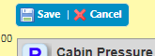
TIP: If there are multiple instances of the same name, you should select the first one spelt correctly, using both upper and lower case letters. Unfortunately there are some rogue data entries so be careful not to select anything which is not a single name and avoid any entry with a contract type attached.

11.2.1 Create New Person
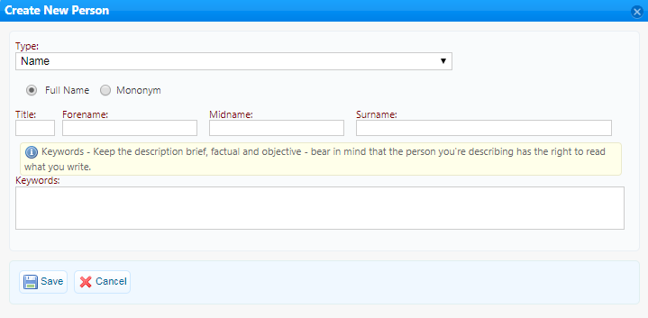
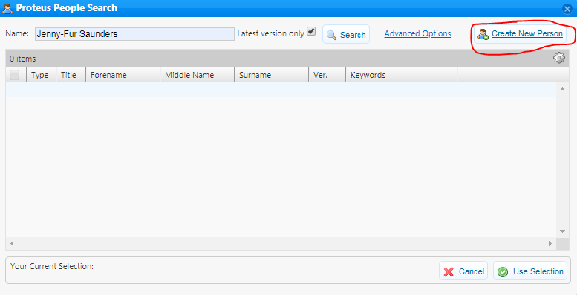
If the person that you need to add is not already in the database, you can create a new person using the button in the top right of the “Proteus People Search” window.
Add all the relevant information, keeping the keywords as clear and concise as possible.
TIP: The option to do this will be greyed out until you have searched for the person. This is to avoid users adding duplicates to the system.

11.2.2 Adding Content Items
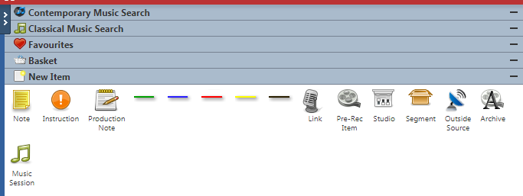
Click the “Edit” button, and open the “New Items” area of your “Right Hand Panel:”

You’ll need a “Pre-Rec Item” for a pre-recorded programme, “Studio” for a live programme. Drag the relevant item onto your running order.
WARNING: Clicking on the “-” symbol at the end of each area of the Right Hand Panel will minimise the area and hide it under a small logo at the top of the Panel. We recommend avoiding clicking on this symbol. To open each area, double click on the title.

In the space where it says “[Empty]”, double click and type a short description of the content. This can be like the medium description but longer and should include “spoilers.” This is for archive and research purposes. Focus on including keywords that describe the subject matter of the programme.
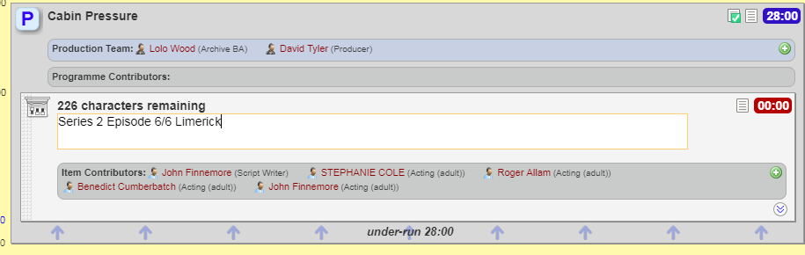
If you mention contributors in this section, you need to describe who they are (job description, company etc.) This section has a character limit of 255. If you need more space, click on the “properties” menu and add the extra details into the “VCS description.”
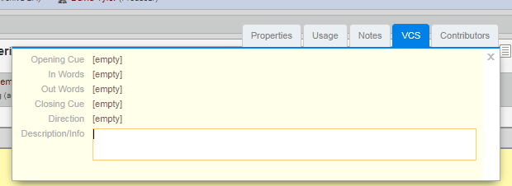

11.3 Adding Contributors
The Academy training video for this is here: https://www.bbc.co.uk/academy/proteus/running-order-add-your-contributors/
It is important to add contributors to each “Running Order Item” in case it is reused in later programmes. You can add these contributors clicking the “Properties” icon on your “Running Order Item”:
Enter edit mode. On the contributors tab click “Add” and then search for your contributors. Add them to the running order and then select from the dropdown list the role performed within that item (e.g. interviewee).
WARNING: Avoid using the “Speech” role. This does not give enough information.

Tick “All Rights” if the clip can be used again without any payment OR add rights details onto Proteus in relevant fields or notes field. Be sure to include the duration of the contribution if the contributor is paid by the minute.
If a contributor has multiple roles, add these using the “Additional Role for this Person” box rather than adding the same contributor twice.
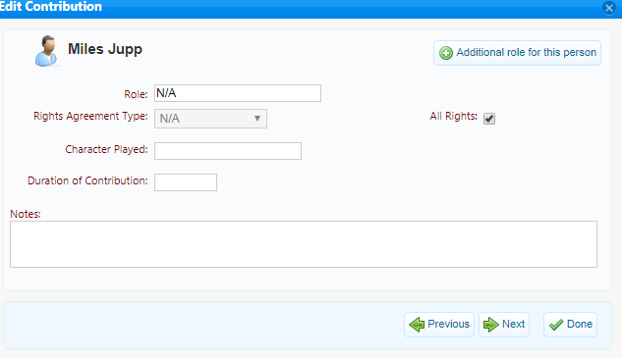

11.4 Adding Archive Items
To add an archive item, drag an archive item from the New Item box into your existing running order item. To make sure it is inside the item, look out for the red line that will appear on the existing item before you drop it.
Fill in the title, contributors, rights and reference detail on the archive tab of Properties as you would for a new item. This data should have been supplied by the original owner of the clip.
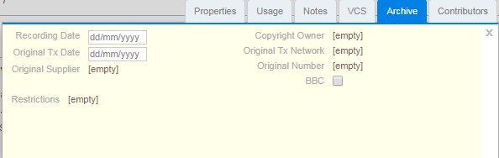
WARNING: You should always use the details of the original transmission of an archive clip, not a repeat or usage in a later programme.

11.5 Adding Music Items
The Academy page for music reporting is here: https://www.bbc.co.uk/academy/proteus/music-reporting/
Open music search in the right hand panel (contemporary search unless you are working for Radio 3 and are familiar with the “Classical Music Database”.)
You may want to widen the “Right Hand Panel” so that you can see all of the search fields. You can do this using the two blue arrows at the edge of the panel:
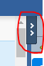
The contemporary music search looks like this:
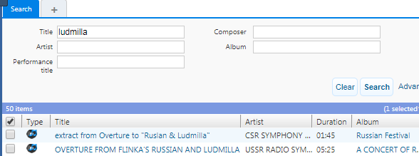
If you need additional search fields, you can click the “Advanced” button which will provide more granular fields.
There are lots of entries in the system. Sometimes they are inaccurate as this database can be updated by all users with “Paperwork Access”. The best way to ensure that you have the correct track is to check using the catalogue number and label.
Search for the track, and drag it into the correct position on your running order – add the relevant duration. This duration should be exact and accurate.
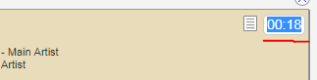
If you can’t find the track, you can add it using the “Create Track” function at the bottom of the search results. You can also use the “Create Track Like” box if, for example, you are adding a track where the album is already in the system, but the specific track you are using is not.
Make sure that you are adding accurate information and avoid duplicating tracks unnecessarily. If you need to delete a track from your running order you can select it and press delete (function and backspace buttons on a mac.)

11.5.1 Music Reporting Codes
If you need to add a new piece of music, you will need to add one of the following codes:​
​A | ​Sound | ​Archives Music on archive material from the BBC Sound Archives.  Label details must be blank!
​C | ​Commercial | ​Compact disc, LP, cassette or cartridge of music, speech and sound effects.  Label details are required, and ISRC if possible.
​H | ​​Radiophonic Workshop | Specially composed material from the Radiophonic Workshop.  Label details must be blank!
​I | ​Local Radio Idents | ​Specially composed idents for Local Radio only.  Label details must be blank!
​K | ​Commercial old | ​Recordings published over 50 years ago.  Label details are required!
​L | ​Live | ​Performance (and miming on live programmes for TV).  Label details must be blank!
​M | ​Library music | ​Publishers library music, speech and sound effects, e.g. Bruton, Carlin, Chappell, De Wolfe.  Label details are required!
​N | ​Private tapes | ​Non-commercial private tapes.  Label details must be blank!
​P | ​Music video | ​Will have an ISRC number on packaging or timeclock. Short form video usually 3-4 mins. Not likely to be cartoons / extracts from feature films / concerts. DVD versions reported in the same way.  ISRC and Label details are required!
​R | ​Studio recording | ​BBC studio or location recording (not specially composed).  Label details must be blank!
​2 | ​2nd or further use of "R" code | ​Within 28 days of the 1st transmission.  Label details must be blank!
​T | ​Soundtrack tape | ​From BBC’s Film Unit or film soundtrack from Programme Acquisitions.  Label details must be blank!
​U | ​Foreign tapes | ​Stock music from Foreign Broadcasters (e.g. EBU tapes).  Put Foreign Tape as the label name!
​X | ​Specially composed music | ​Excluding Radiophonic Workshop.  Label details must be blank!
TIP: If you use the same content items, contributors or music items frequently – drag and drop them into your “Favourites” in the “Right Hand Panel”. Then you drag them straight from your favourites to your running order without having to search.

11.6 Paperwork Complete
Once you are completely sure that you have added all your relevant information to your running order, you can click the “Paperwork Complete” button. You should be absolutely certain that the details are correct before clicking “Paperwork Complete”. This button will lock the running order any to further editing.
If you have made an error and need to make changes you will need the programme to be ‘unlocked’ by proteus.support@bbc.co.uk . Please note that unlocking the paperwork could take up to working 3 days.

12 Music Report
Once all music is added and the correct durations are entered you are ready to submit the “Music Report”. Please note that you can only click “Send Music Report” from one hour after the programme has been transmitted.
Music reporting is required for all BBC programmes. You need to send the music report even if there is no music included in the programme.
TIP: You can add your music to your running order in advance of the transmission. However, you will not be able to send it until after transmission.

TIP: If you are supplying a live programme and use dira! or SADiE to report music you do not need to enter the music information into Proteus.
For straight repeats (where the origination has been reported in Proteus), the music report will be sent automatically by the system. If there is an edited repeat of the programme (otherwise known as a re-versioned repeat), you will need to search for the repeat transmission, edit the running order as required, and send the music report again. This is because an edited repeat is considered a new programme, with a new running order.
The Academy training page for sending your music report is available here: https://www.bbc.co.uk/academy/proteus/music-reporting
WARNING: It is not possible to send the music reporting before the programme has been transmitted.

13 Sending the Music Report
When all music items have been added to the running order double check that each item has the correct duration and all the information required has been entered (i.e. composer, publisher, album, etc).
WARNING: The duration listed in your running order should reflect the amount of time that the piece is played in the programme, not the full duration of the track.
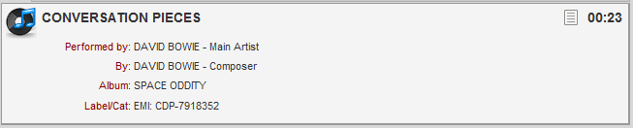
Check that the “Sig Tune”/ “Dubbed” boxes have been ticked, if relevant.
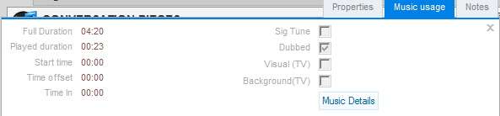
To submit the music report click the “Send Music Report” button located at the top of the running order, in the part of the header which contains the transmission details.
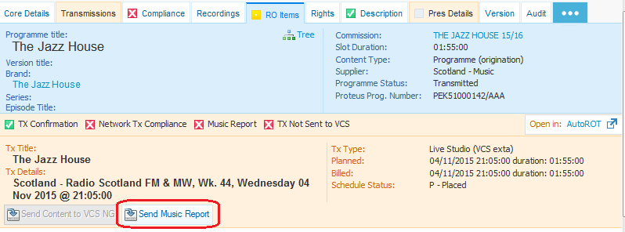
A pop-up window will appear and display the number of music items due to be sent. Check that it reflects the expected number of music items (if not, return to the running order and make any necessary adjustments). If correct then click “Yes”.
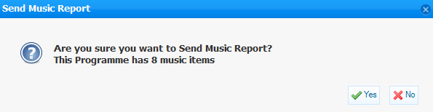
When the report has been sent, the “Music Report Status” will change to amber. This indicates that the transfer of music data to the BBC Music Reporting Unit is 'Pending'. The transfer will take place overnight.
The status is visible on the transmission header:
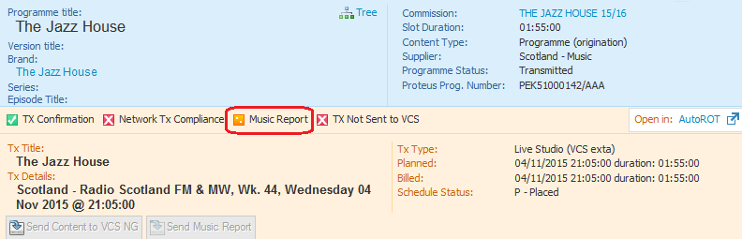

The “Music Report Status” is also visible on the “Programme/Tx Search Results” screen:
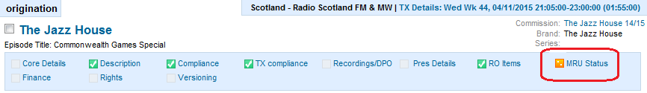
The following day, when the transfer is complete, the status will change from amber to green (Received) status:

14 Correcting Errors When the Music Report Has Been Sent
If you have already clicked the “Send Music Report” button and then discover you have made a mistake you can do one of the following:
- If the “Music Report Status” is still amber (Pending), it means that the system has not yet sent the music report to the BBC Music Reporting Unit. You can then click “Edit”, make any corrections to the music items, and then click “Save”.
- If the “Music Report Status” has changed to green (Received), the original music information has been received by the BBC Music Reporting Unit. Click “Edit”, make any corrections to the music, click “Save”. The system will display the following message which enables you to re-send the music report.
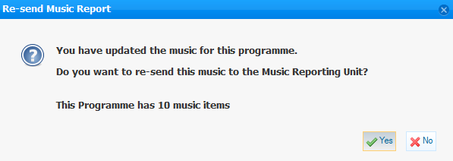
WARNING: if you have already clicked the “Paperwork Complete” button, it may not be possible for you to edit the running order and correct any music errors!
Contact proteus.support@bbc.co.uk if you need to edit a “Paperwork Complete” running order.

